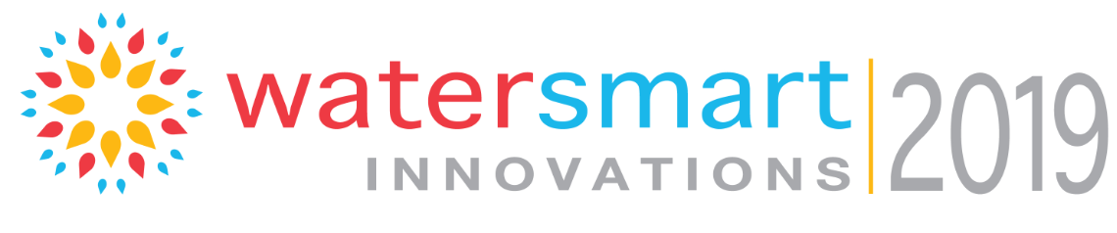

WaterSmart Innovation Conference and Exposition Call for Abstract Guidelines
Professionals working in disciplines related to urban water efficiency, water resource conservation, supply- and demand-management, and water re-use are invited to submit a paper for consideration as a presenter at the 12th annual WaterSmart Innovations Conference and Exposition, slated for October 2-3 in Las Vegas.
Event organizers hope to build upon the successes of previous WSI conferences, which serves to broaden the knowledge of innovations in water conservation and efficiency including products, programs and outreach. WSI organizers will consider all topics related to innovations in water conservation; potential topics include:
- Water/Energy Production Nexus
- Drought Management
- Alternate Sources
- Rainwater/Greywater/Storm-water Harvesting
- Sustainable Construction and Development
- High Efficiency Fixtures and Appliances
- Policy Development/Public Outreach
- Landscapes and Outdoor Water Use
- Marketing
- Conservation and Incentives
- Education (youth, adult)
- Water Loss Management
- Water Efficiency and the Environment

Please follow these guidelines when submitting your abstract;
- Limit abstract size to no more than one page
- Please indicate which of the above topics your abstract falls into, if you are unsure please designate “Special Topics”.
- Please indicate your contact information: Organization, email, phone, address.
- Abstracts with “Commercial” content will not be reviewed

Deadline and how to submit:
Abstracts should be submitted via email to patrick.watson@snwa.com no later than: Thursday, February 28, 2019
Notification of acceptance:
Abstract chosen for presentation will be notified by email no later than Monday, April 29, 2019

